The Parish of St Peter’s Dunchurch

with St Edmund’s Thurlaston

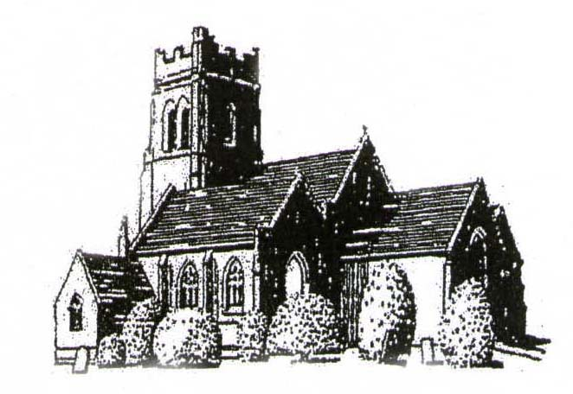
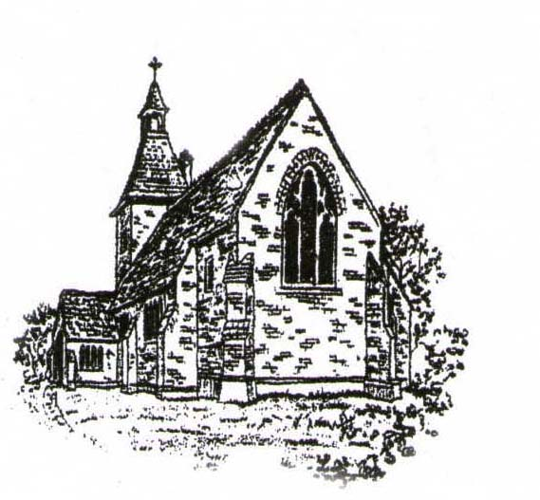

Weddings at St Peter’s and St Edmunds



We are delighted that you have chosen our parish church for your wedding. These notes are designed to answer some, if not all, of the queries that you might have.
Your wedding day will be an event that you will remember for the rest of your life. Our aim is to do all that we can to ensure that your wedding will be a really wonderful occasion. If you are unsure, or have any questions we haven’t thought of, please ask—we are here to help.

Contact Details:
The Churchwardens dunchurchstpeters@gmail.com
Mrs Veronica Lowe 079893 50017
Mrs Celia Jones 07712936355



Preparation for Marriage
A marriage is more than just the wedding day and you will be thinking about how to make your marriage a good one; one in which both of you will grow and flourish throughout your life together. You will be required to have some form of marriage preparation. This will take the form of several meetings as individual couples with the priest who will officiate.

The wedding interview and rehearsal
At your initial interview with the officiating priest you will be asked to provide all the necessary details to ensure that your marriage will be valid and also for the completion of the marriage registers. You will discuss the arrangements for the service, choice of hymns, music, readings, printed orders of service et cetera.
Nearer the time, the date and time for a rehearsal of the wedding service will be arranged. This will usually be on a date just prior to the wedding. The rehearsal gives you a chance to walk through the service so that you are well prepared. As well as the bride and groom the rehearsal should also be attended, wherever possible, by the whole wedding party including the best man, chief bridesmaid, bride’s supporter (whoever is to walk her down the aisle), ushers and parents.
If you haven’t already supplied them, please bring to the rehearsal your banns certificate (where banns were read in another church) and any outstanding fees.

The legal side
This is obviously important—for your sake we have to get it right! If anything written here is not understood, please ask for further clarification.
Marriage law requires that we confirm the identity, nationality and date of birth of those we marry. You may be required to show documentary proof of this and of your current address. Please note that a driving licence does not prove nationality.
In what follows, the term ‘parish’ refers to the ecclesiastical parish of St Peter and St Edmund, not the secular parish of Dunchurch.

Where at least one person's home is in the parish:
If the home of either the bride or the groom is in the parish and has been so for at least six months, then you can be married at St Peter's.

Where neither person lives in the parish but where one of them has been a regular worshipper here for at least six months:
If neither the bride nor the groom live within the parish boundaries, but one of you is a regular worshipper at St Peter's or St Edmund's, you can still be married at St Peter's. We define ‘regular’ as attending Sunday worship at least once per month for least six months before the banns are to be read. You will be required to confirm your attendance on each occasion, either by e-mail or by speaking to the churchwardens or one of team who assist with weddings.

Where neither person lives in the parish but where one of them has a firm link with the parish:
If neither the bride nor the groom live within the parish, and you do not regularly worship at St Peter's or St Edmund's, you may still be married at one of these churches if you have a firm link with the parish as defined by the Church of England Marriage Measure 2008.
If you have been married before, there are restrictions concerning re-marriage in church. You will need to arrange a confidential discussion with the officiating priest before a date for your marriage can be confirmed.

Reading of Banns
It is a legal requirement that your intention to be married is publicised, so that anyone who has a reasonable objection to the marriage has an opportunity to do so. Normally this is done by calling banns, but under certain circumstances you may need to acquire a special licence to marry (in which case banns will not be announced). This will be explained if your circumstances require it.
The banns are read on three separate occasions, at morning services in the parish, normally on the second, third and fourth Sundays of the month two months before you are to be married. It is desirable you that attend as many times as possible so that parishioners can meet you and support you in prayer.
If either of you does not live in the parish, there will be a need for banns to be called in your local parish(es). How to do this will be explained to you. After the banns have been called in the other parish, you will be issued with a certificate confirming there was no justifiable objection to the marriage. The officiating priest will need to have seen this certificate before the wedding can take place. Usually you can bring it to the wedding rehearsal but you may wish to pass it on as soon as you get it in order to facilitate the paperwork and avoid a last-minute panic.

Weddings at St Edmund’s, Thurlaston
Any wedding proposed at St Edmund’s will require a special licence, as this building is not licensed for marriages.

Wedding Blessing
If we are unable to agree to your request for a marriage in one of the churches because of some insurmountable obstacle, we are normally still happy to offer a service of Prayers and Dedication after Civil Marriage.

Church and legal fees
A non-refundable deposit of £50.00 is payable on booking the wedding. (Cash, or cheque payable to “The PCC of Dunchurch Parish” or by deposit into account number 01089602, sort code 30-97-17. In the latter case please send proof of payment to the churchwarden.) In addition to the church fees you will also need to pay the organist and the bell ringers separately. You will find the current fees inserted in this brochure. All fees must be settled before the wedding.

The Service
At St Peter’s we use the Church of England’s modern ‘Common Worship’ service.
There are usually 2 or 3 hymns, for which you may need an organist. Either the organist can play music for the entry of the bride, during the signing of the registers and for the procession at the end of the service, or you can provide music on a CD. However, you will need to be sure that there are no copyright problems with the recordings you choose—please consult with the organist if you are unsure.

Printed Order of Service
It is not really necessary to have a printed order of service, but if you would like to do this then please discuss with the officiating priest what should be included making any arrangements for printing.

Planning and Timing on the Big Day
The time we book for the wedding is the time for the service to start. If timings go badly wrong it may be necessary to drop verses from hymns, cut readings, etc. in order to keep within the allotted time.
You will need to arrange with your photographer, if you’re having one, how long will be needed before the service to photograph the groom, best man, bride and bridesmaids so that you can book the cars and arrange with your drivers accordingly. Please note that the groom and best man should allow arrival a minimum of 45 minutes before the service for legal preparations with the minister and you should allow for this in your timings.
The service generally takes around 45 minutes, depending on readings and music chosen, then you will need to allow additional time for photographs afterwards before you plan to arrive at your reception.

Ushers
It would be helpful if you could choose two or three people to be ushers at the service. Their duties are to welcome your guests, to hand them service sheets or hymn books and to guide them to their seats. During the service they can assist the verger in dealing with any unforeseen circumstances which may arise. At the end of the service they should collect hymn books from the pews, gather up the service sheets and check for items left behind by guests. They should also collect the wedding candle, if one is used.
We will arrange to reserve at least the front 2 or 3 rows in church for the groom and best man, for the bridesmaids and for the couple’s parents/immediate family.

Photography
Only photographs by an official photographer may be taken in the church during the service. Please advise your guests accordingly. The photographer may not use flash or lights must stay in one place throughout the service (by the font) except for during the entrance of the bride and during the signing of the register.
Please ask your official photographer to have a word with the minister or verger before the service begins. In the churchyard please do not have your photographs taken near any recent graves, as this can be upsetting for families in grief. Ask for guidance about the best places to take photographs.
If you would like to have the service professionally recorded on video, please ask the videographer to talk to the minister or verger before the service for guidance about the best place stand. Please note that the videographer, like the photographer, is not permitted to move around during the service.
Only the official videographer may record the service. (There is an additional fee for this to cover copyright administration. It is payable to the organist and must be discussed with him or her.) Please ensure that your videographer has a Limited Manufacture Licence (obtainable from www.PRSforMusic.com) to be able to record the sound from the organ, group, soloist, music played on CDs/DVDs, etc.

Confetti
Bio-degradable confetti may be thrown in the Churchyard but only near the main gates. Rose petals may not be scattered inside the church.

Organist
The wardens or the priest officiating at the wedding will put you in touch with an organist to discuss your choice of music and the fee payable. Please contact the organist as soon as possible to confirm your booking.
If you are not having an order of service printed, then the hymns you choose must be selected from one of the church hymn books, which are Singing the Faith and Mission Praise.

Bells
St Peter’s has a fine peal of six bells which may be rung at your wedding, providing the ringers are available. This facility is to be arranged directly with the bell ringers, not with the priest. The fee is payable direct to the Tower Captain. You will need to contact the Tower Captain, Mr Simon Benton (0789 0325434) as soon as possible.
Please note that if you are very late for the service, the bellringers may have to leave and you may not have bells!

Flowers
The following notes are provided for the information of the person you ask to do the flower arranging for your wedding.
Throughout most of the church's yearly calendar, flower arrangements are placed in the Chancel and the Lady Chapel and are changed every two weeks. If you intend to have a florist supplement the church arrangements then please let the Wedding Coordinator (Celia Jones – 07712936355) know.
Please bear in mind that the church is a much-used building, particularly on Sundays when seventy or more people, including young children attend. Large flower arrangements in certain places can be very much in the way and are liable to be damaged by people brushing past.
Places suitable for decoration.
The Sanctuary – a small arrangement on a pedestal to one side of the altar. But this must not restrict access to both ends and the rear of the altar.
The Old Font – at the base of the pulpit.
The Lectern – a pedestal close to this.
The Lady Chapel, window sills and back pillars – may have pedestals by them.
The Font – may have a small, low arrangement.
Pew ends – No sticky tape to be used. It never works and it also ruins the polish on the pews!
Please do not hang arrangements on the brass work as it is fragile.
Sunday service flowers are always at the Altar and Lady Chapel.
Artificial flowers are not permitted.
When arrangements are placed on wood, mats must be used.
In the unlikely even of there being more than one wedding on the same day, you will be given the contact number of the other families so that you have the opportunity to co-ordinate your flowers and share costs.
Please ask your florist to contact Celia Jones to see when the church is available and unlocked for floral decorations to be done.
If your wedding is over the Easter, Christmas or Harvest period the church will already be decorated with celebration flowers.
All flowers put in the church are for the glory of God therefore they may not be removed.

Times of Services at St Peter’s or St Edmund’s
Details of Sunday services can be found on the website …
www.stpeters-dunchurch.org
… or on the weekly or monthly news-sheets available in the church.

